Middle School Handbook Supplement

This Handbook provides information unique to Lexington Middle School and is supplemental to the District Student/Parent/Activities Handbook.

Absences and Homework
Upon return from every absence or partial-day absence, students shall confer with their teachers about missed classwork:
(a) students who are pre-excused from school should have all of their schoolwork completed and turned in to the teacher before leaving school unless special arrangements have been made by the teacher and/or administrator;

(b) students who miss school due to an illness or other unforeseen circumstance will be allowed two (2) days for each day absent – up to five days total – to turn in missed homework given during the absence; additional days may be allowed by the teacher and/or administrator for special circumstances;

(c) suspended students must have all homework completed upon returning to school and shall be assigned in-school suspension if otherwise.

Accountability List
- An “Accountability List” will be published every Monday morning by 8:30 AM. Teachers are required to update all grades by 3:30 p.m. Friday.
- “Failing” are those whose present QUARTER/TERM grade average is below 70%.
- A student on the failing list for two or more consecutive weeks in one or more subjects is considered ineligible.
- A student is ineligible - starting Monday after the list is published - until the following Monday. If the student is passing the subject(s) that caused the ineligibility, s/he shall be eligible that following Monday.
- Students will not be allowed to participate in contests while they are ineligible.
- Each student has the right to have his eligibility reviewed.
- Eligibility will cover all extra curricular activities under the jurisdiction of the school.

Behavioral Expectations
Please see chart contained in this document for typical disciplinary responses to various rule infractions.

Cafeteria Rules
- All food is to be eaten by the student or left on the tray when returned to the dishwasher. All straws, papers, milk cartons should be deposited in the trash cans. All leftover food should be scraped off the tray on to the correct container.
- Forks and spoons should be placed in the pan with water, not thrown away.
- Students are to use proper manners including eating quietly.
- There will be no throwing of food or other items.
- Students should remain at their tables until they are dismissed. Students are expected to eat lunch at school. For a student to eat at home, parents must provide written authorization and transportation.
- Students must treat lunch personnel with respect.
- Students who violate the above rules will be disciplined.

Payment for Meals
Students are encouraged to pay for meals several weeks in advance. Payment should be made to the bookkeeper in the office.

Cell Phones and Other Electronic Devices (Policy 6025)
Students may not use cellular (cell) phones or other electronic devices (e.g. beepers, ear buds, cellular telephones, MP3/CD players, radio headphones, laser lights, personal computers, etc.) while at school, except as permitted in this handbook.

Students may use cell phones or other electronic devices outside the building before and after school. Students may not have cell phones or other electronic devices while they are in locker rooms, classrooms or restrooms. During school hours students must keep their cell phones or other electronic devices in lockers or a personal vehicle.

Students may not use cell phones or other electronic devices while riding in a school vehicle unless they have express permission to do so from the vehicle’s driver.

Students are personally and solely responsible for the security of their cell phones and other electronic devices. The school district is not responsible for theft, loss or damage of a cell phone or any calls made on a cell phone.

Students who violate this policy will have their cell phones or other electronic devices confiscated immediately. The administration will return confiscated devices to the offending student’s parent or guardian after meeting with the parent or guardian to discuss the violation. Students who violate this policy may, at the discretion of the school’s administration, be subject to additional discipline, up to and including suspension or expulsion.

Additional information about cell phones is provided in board policy.

Coats and Boots
Middle School students must wear coats outdoors when the weather makes it advisable. The staff will decide when coats are required for recess.

Middle School students may choose to wear overshoes or boots when the playground is wet or muddy. Waterproof boots worn to school should be taken off and regular shoes worn during the day. Boots worn to school must be marked with the student’s name.

Grades
Students will receive letter grades for their academic core classes.

The middle school grading system is as follows:
A + 99%-100% 4.1
A 93%-98% 4.0
B + 91%-92% 3.5
B 85%-90% 3.0
C + 83%-84% 2.5
C 78%-82% 2.0
D + 76%-77% 1.5
D 70%-75% 1.0
F 69%-0% 0.0

Homework
Classroom teachers will often assign homework. Parents who have questions about homework or concerns about class work should contact the teacher. Questions not resolved by the teacher should be referred to the administration.

Each student is expected to spend some time preparing for studies outside of school hours. The amount of time that is needed will depend upon each student.

Students who struggle to complete assignments or who must spend an inordinate amount of time completing an assignment should seek the help and advice of their teachers and consult with the principal and/or the guidance counselor.

Honor Roll
To qualify for the honor roll, students must be enrolled in a minimum of seven (7) classes, four of which must be from the core curriculum of English, mathematics, science, social studies, business education, foreign language and computer science. Students who earn a quarter or semester academic average of 92% or better with no grade in any class lower than 90% will qualify for the honor roll.

Playground Rules
Students must follow these rules to keep the playground safe:
1. Students must obey the playground supervisor at all times.
2. Students may not enter the street/highway to retrieve a ball unless given permission by the playground supervisor.
3. Students must play away from the school windows.
4. Touch and flag football are permitted, but tackle football is prohibited. Students may only play football on grassy areas.
5. Students may throw balls and other authorized play equipment. They may not throw rocks, gravel, snowballs, and clothing.
6. Students must use the playground equipment properly and in a safe manner.
7. Students may not leave the playground after they have arrived at school for the day.

Students who violate these rules will be disciplined with the loss of recess or other privileges, detention and/or other consequences.

School staff supervise the playground during school hours. However, it is not supervised after school, and students should not play on the equipment without adult supervision.

School Day
The school day typically begins at 8:00 a.m. and ends at 3:25 p.m. Students are to leave the school grounds after dismissal. School staff will provide supervision for students on school grounds 15 minutes before the school day begins and 20 minutes after the school day ends. There will be no supervision provided by the school before or after these times. Parents must make arrangements for their children to leave school promptly at the end of the day.

Student Government (Policy 5041)
Students are encouraged to formulate and participate in elective and representative student government activities. The organization, operation and scope of the student government shall be administered by the superintendent or designee.

Visitors (Policy 5064)
We welcome and urge visitation by parents. However, in order to ensure the safety and well being of our school community, all visitors must check into the high school office upon arrival in the building.

Weapons
In addition to the regulations outlined in the District Student/Parent Handbook, please comply with the terms contained in the following notice.

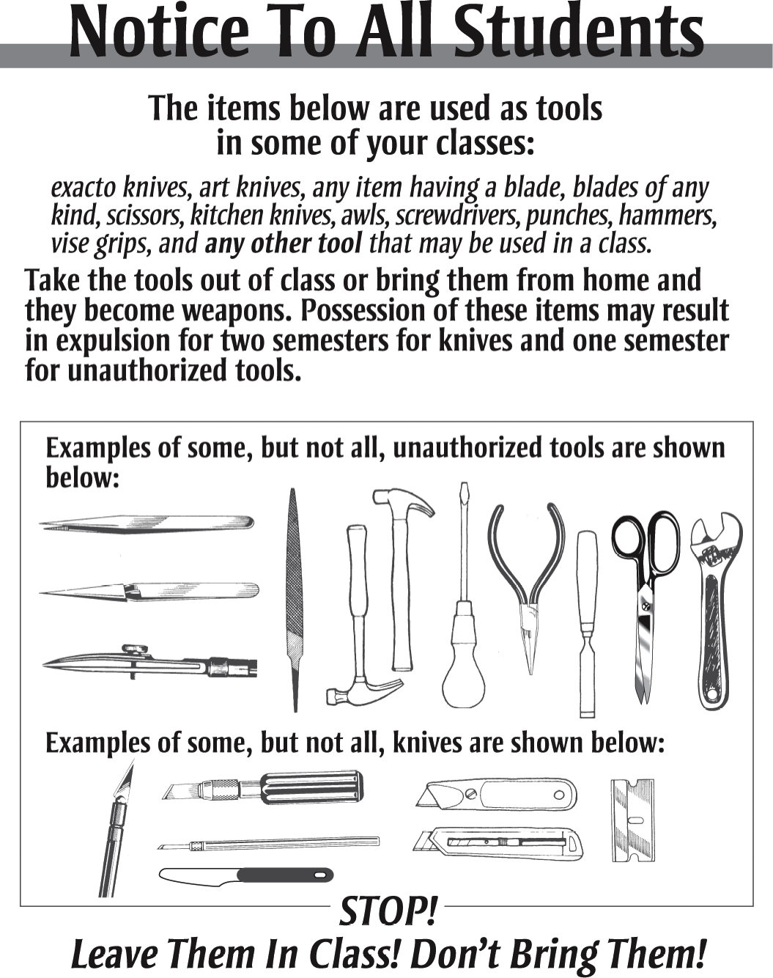

CONSEQUENCES FOR DISRUPTIVE ACTS
The below-listed consequences are guidelines to be used for dealing with disruptive acts. The consequences may change depending on circumstances. Other consequences such as in-school suspension may be utilized at the discretion of the LHS administration. In some situations, the Extracurricular Policy may also be in force.
DISRUPTIVE ACT 1ST OFFENSE 2ND OFFENSE 3RD OFFENSE
Academic Misconduct; (includes cheating, plagiarism, etc.) | Detention; “0” credit for assignment (student may redo assignment for 69% credit or less); Parent Contact | ISS; “0” credit for assignment (student may redo assignment for 69% credit or less); Parent Contact |  | S-OSS; “0” credit for assignment (student may redo assignment for 69% credit or less); Parent Contact
Activities Misconduct (Includes Derogatory Comments to Participants; Unruly Behavior; Disrespect to Officials; Failure to Follow Rules or Requests, etc.) | Warning, Detention, ISS, or S-OSS; Possible directive to leave event and/or ban from future activities; Parent Contact | Detention, ISS or S-OSS; Directive to leave event; Ban from future activities; Parent Contact |  | N/A
Alcohol* (use and/or possession)  [+ Extracurricular Policy Consequence] | Minimum 5 days OSS or ***See below | ***See below |  | ***See below
Arson*** | ***See below
Assault  - Against a student*  - Against school staff*  - Mutual consent/equal participation*  - Bullying, Threats, Harassment* | OSS for balance of the day; Min. 5 days OSS & *See below. | Long-term suspension or expulsion. |  | Expulsion
 | Expulsion | Expulsion |  | Expulsion
 | OSS for balance of the day; Minimum 5 days OSS | Long-term suspension or expulsion. |  | Expulsion
 | ISS or OSS | ***See below |  | ***See below
Bomb Incident* (includes threat) | ***See below | ***See below |  | N/A
Bus/School Vehicle Violation (includes horseplay, failure to follow directions, littering, throwing objects out of the windows, etc.) | Warning; Possible Detention, ISS, S-OSS and suspension from bus route; Parent Contact | Warning; Possible Detention, ISS, S-OSS and suspension from bus route; Parent Contact |  | Suspension from bus service;  Parent Contact
Class Disturbance | Consequences to be handled by the classroom teacher. Excessive disturbances will be reported to the administration.
Dress Code Violations | Warning and Change Attire |  | Detention or ISS; Change Attire; Parent Contact |  | Detention, ISS or S-OSS; Change Attire; Parent Contact
Disrespect/Insubordination | Detention, ISS, OSS and/or reassignment |  | Min.5-Day OSS and/or reassignment |  | ***See below
Drug Offenses* [includes actual/imitation controlled substance and paraphernalia]  - Possession/Use  - Sale/Distribution | Min. 5 days OSS /***See below  ***See below |  | ***See below  ***See below |  | ***See below  ***See below
Fire Alarms/Fire Extinguishers* | 5 days OSS and **See below
Fire Paraphernalia [Lighters, matches, etc.]  - Possession  - Unauthorized Use | Confiscate; Detention or ISS  OSS |  | Confiscate and OSS 3-5 Days  OSS and Restitution |  | Confiscate & ***See below  ***See below
Fireworks*  - Possession  - Use | Minimum 5 days OSS  5 days OSS or ***See below |  | Confiscate and OSS 3-5 days  OSS and Restitution |  | Confiscate & ***See below  ***See below

Gang Involvement* (includes graffiti, notes, symbols, hand signs, colors, speech, etc.) | OSS for balance of the day;  Minimum 5 days OSS  1-5 days OSS |  | Long-Term Suspension |  | Expulsion
Larceny/Theft**  - Less than $50  - Greater than $50 | 1-5 Days OSS  5 Days OSS or ***See below |  | ***See below  ***See below |  | ***See below  ***See below
Littering on School Premises | Warning |  | Detention; Parent Contact |  | ISS; Parent Contact
Parking Violations | Vehicles parked in a teacher/visitor lot or illegally parked will be ticketed, booted, and/or towed at owner’s expense.
Public Display of Affection (P.D.A.) | Warning |  | Detention and Parent Contact |  | ISS and Parent Contact
Sex Offenses* (includes possession and/or distribution of sexually-related material (including via electronic devices; “sexting,” etc.) | ***See below
Tardiness, Truancy, and Unexcused Absences | *See “Attendance” section of Lexington HS Student Handbook
Tobacco* (use and/or possession) –includes E-cigarettes | * Confiscate and 1 day OSS | * Confiscate and 2 day OSS |  | * Confiscate and 3 day OSS
Trespassing* (non-students) | Warning and/or *Police notification | *Police notification;  charges requested |  | *Police notification;  charges requested
Vandalism** (Includes property loss/damage, graffiti, abuse of school property, etc.)  - Less than $50  - Greater than $50 | 1-5 days OSS and restitution  5 days OSS and ***See below | ***See below  ***See below |  | ***See below  ***See below
Weapons/Firearms*  - Possession and/or Use | *See “Weapons/Firearms” section of Nebraska Student Discipline Act
Any Other Felony Violations | OSS and/or ***See below

CLARIFICATIONS:
- Students under recommendation for expulsion will be suspended pending the expulsion decision.
- A parent conference may be necessary prior to a suspended student’s return to school.
- Students suspended from school will be allowed to complete missed assignments, homework, and tests.
- Administration will deal with each infraction individually and determine the best, most appropriate action (this may deviate from the stated policy in special situations)
DEFINITIONS:
ISS = In-School Suspension [Short term = 1 day; Long term = 3 days]
OSS = Out-of-School Suspension [S-OSS > Short term = 1-5 days; L-OSS > Long term = 6-19 days]

Expulsion = Suspension for more than 19 days to the end of the semester or up to one year.

INDICATORS:
* LAW ENFORCEMENT NOTIFICATION
** LAW ENFORCEMENT NOTIFICATION AND RESTITUTION
*** LONG-TERM SUSPENSION, EXPULSION OR MANDATORY REASSIGNMENT -
- In accordance with state statutes
- Could also include law enforcement notification and/or restitution

